ព្រះរាជាណាចក្រកម្ពុជា

ជាតិ​ សាសនា ព្រះមហាក្សត្រ

Institute of technology of Cambodia

Department of Information and communication Engineering



The lesson taking about basic of loop and prime numbers

TP5-Loop (for loop while loop and do while loop)

TP: Algorithm and Programming

Lecturer: BOU CHANNA

Student: VEN THON

ID: e20191250

Group: I3-GIC-C

Year: 2021-2022

Contents

Problem1 3

Problem2 3

Problem3 4

Problem4 4

Problem5 5

Problem6 5

Problem7 6

Problem8 6

Problem9 7

Problem10 7

Problem11 8

Probnlem12 8

Problem13 9

Problem14 9

Problem15 10

Problem16 10

Problem17 11

Problem19 12

Problem1: Write a c program to print natural number from 1 to n using while loop

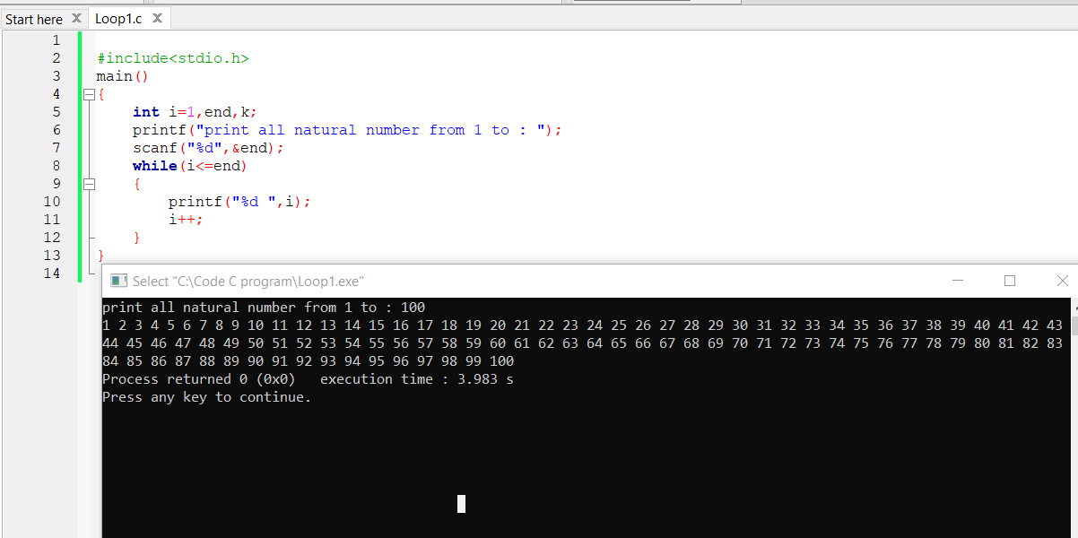a

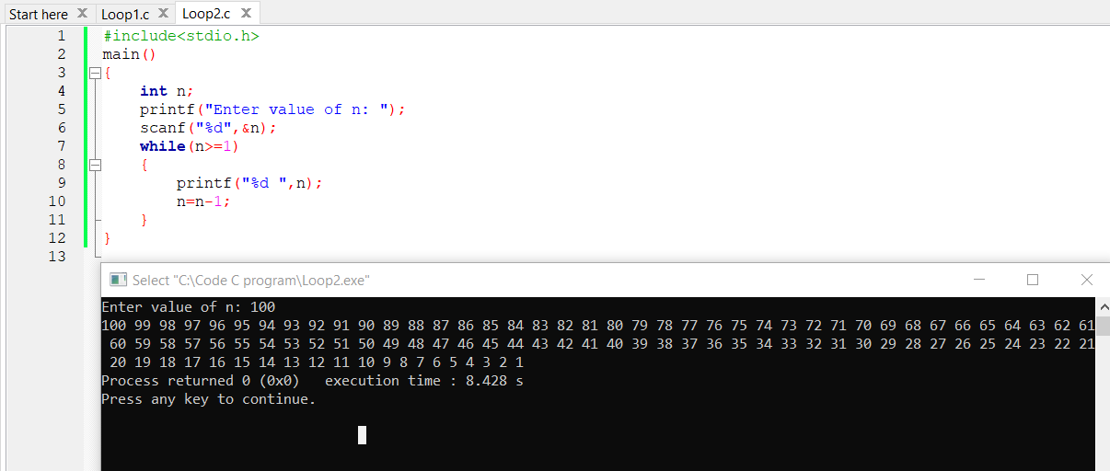Problem2: write c programing to print all natural number in serverse n to 1 using while loop.

Problem3: write c program to print all alphabets a to z using while loop.

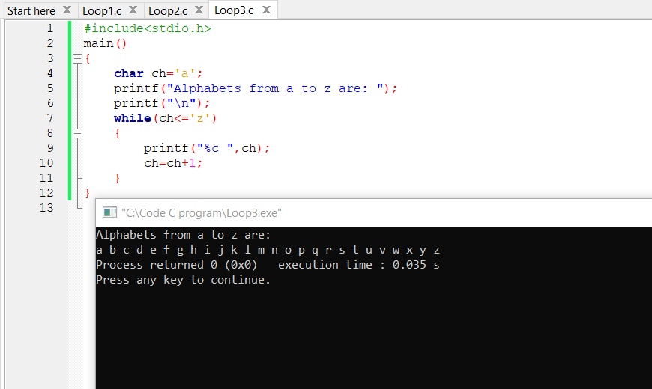

Problem4: write c program to print all even number between 1 to 100 using while loop.

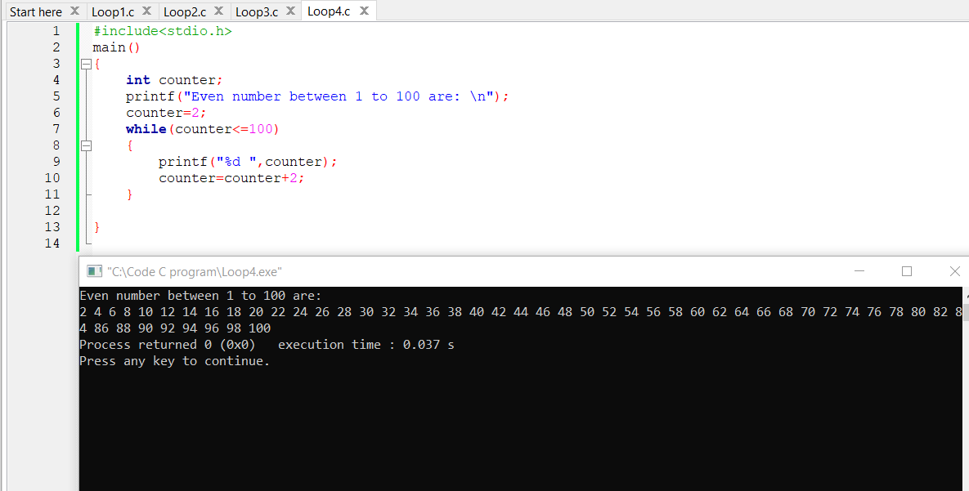a

Problem5: write c program to print all odd number between 1 to 100.

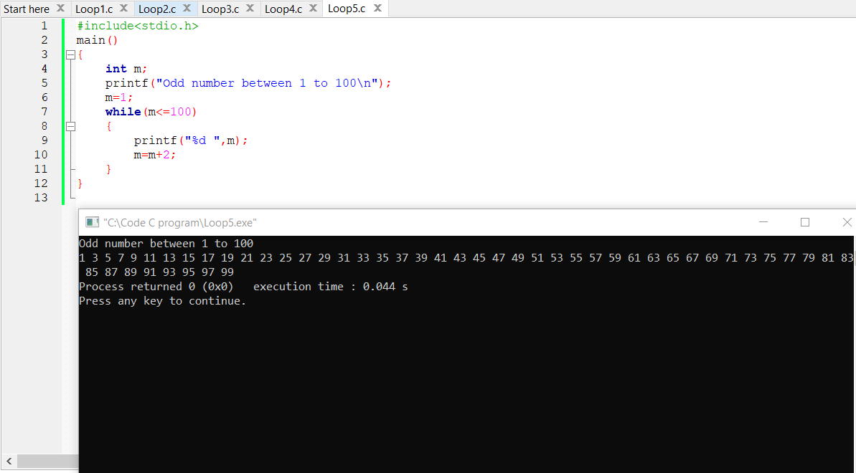

Problem6: write c program to count number of digits in a number.

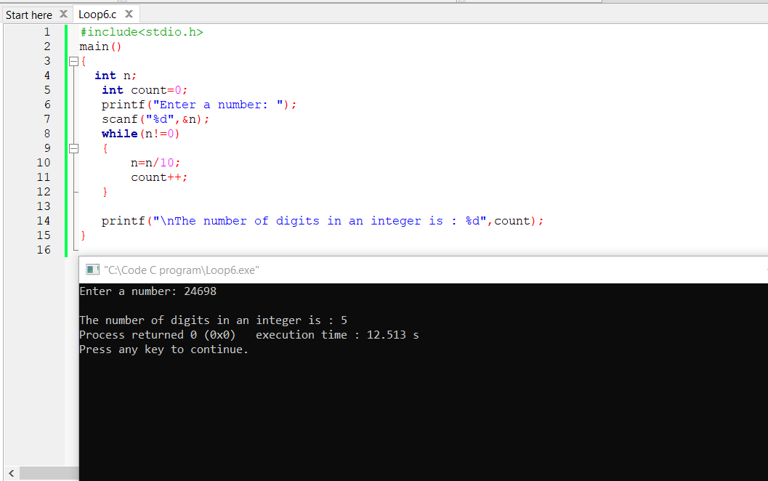

Problem7: Write c program to calculate sum of digits of number .

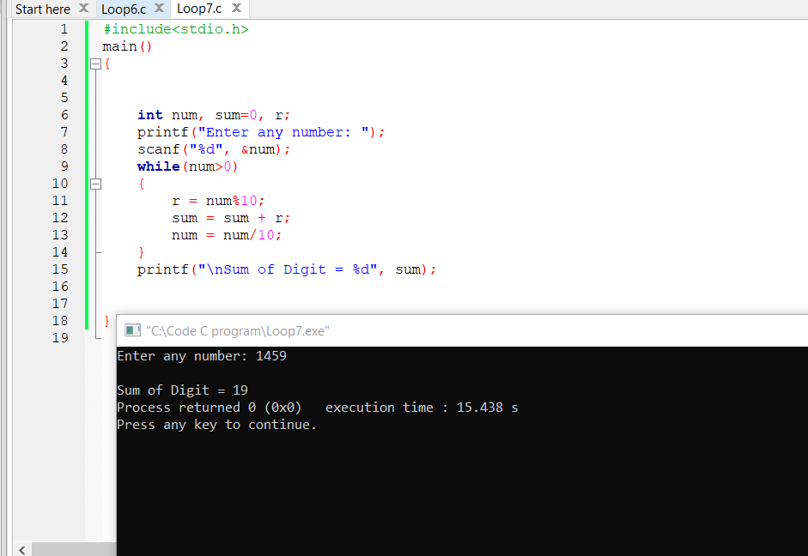a

Problem8: Write a c program to display all primary number between[n,m].

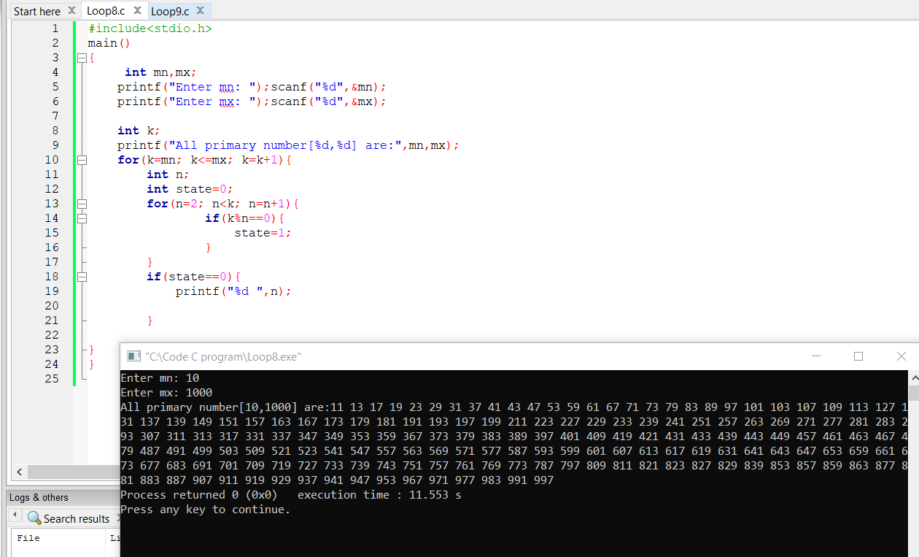

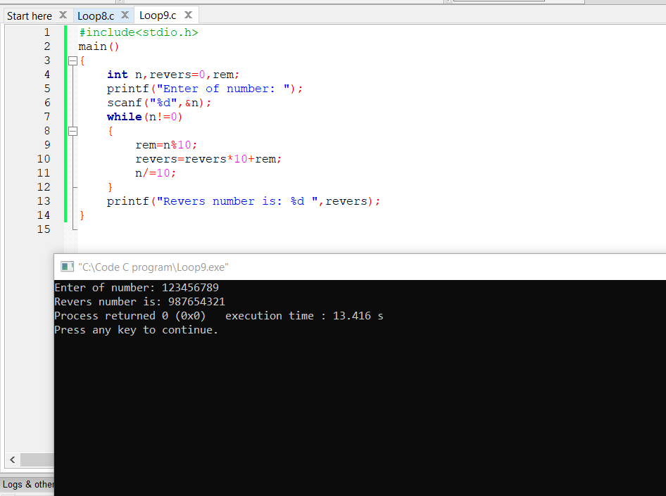Problem9: Write a c program enter a number and print severse.

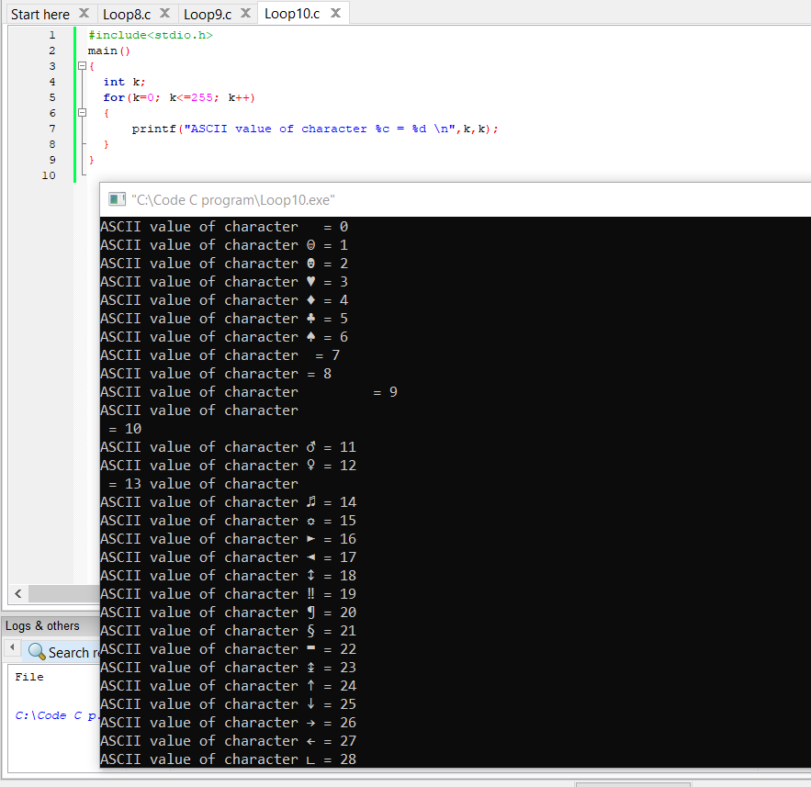Problem10: Write a c program to print all ASCII codes 0 to 255 and character.

Problem11: write c program to find power of number using for loop.

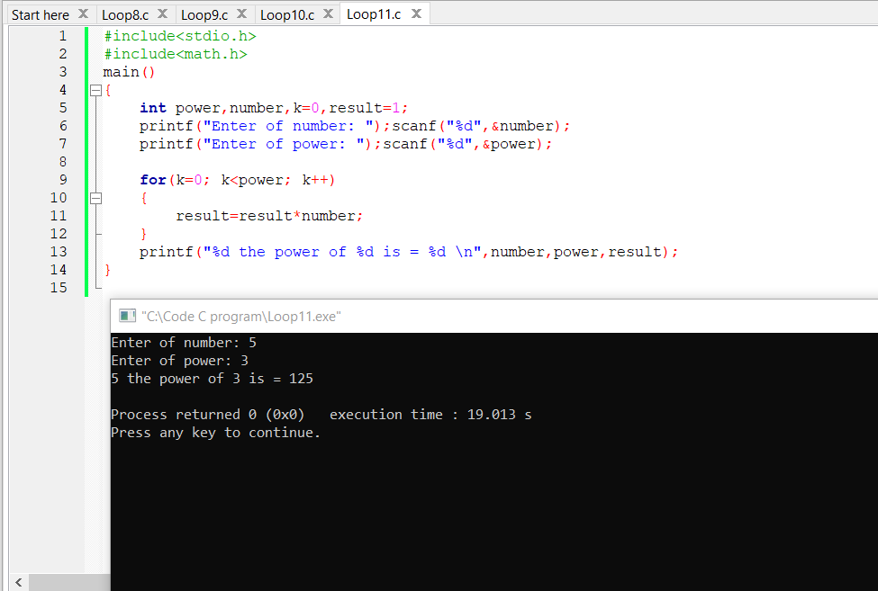

Probnlem12: write c program to calculate factorial of number.

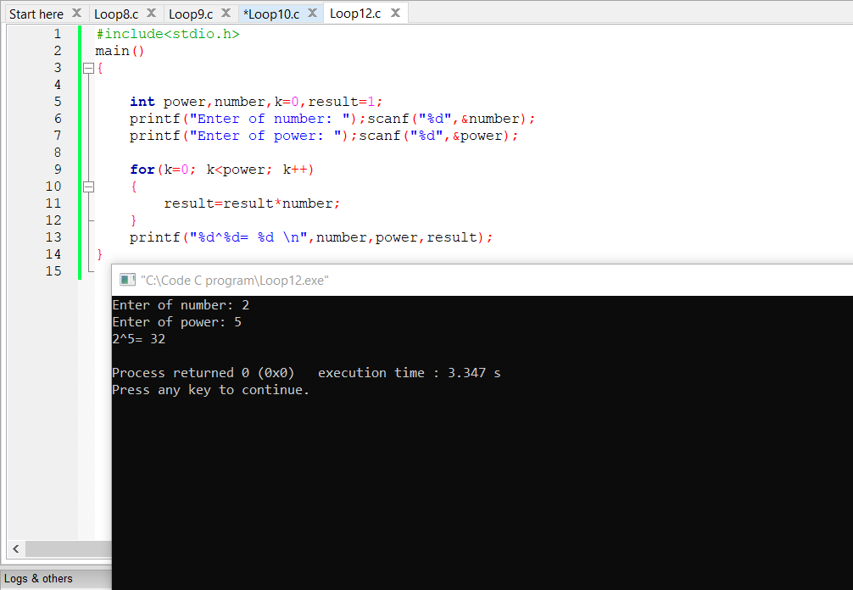

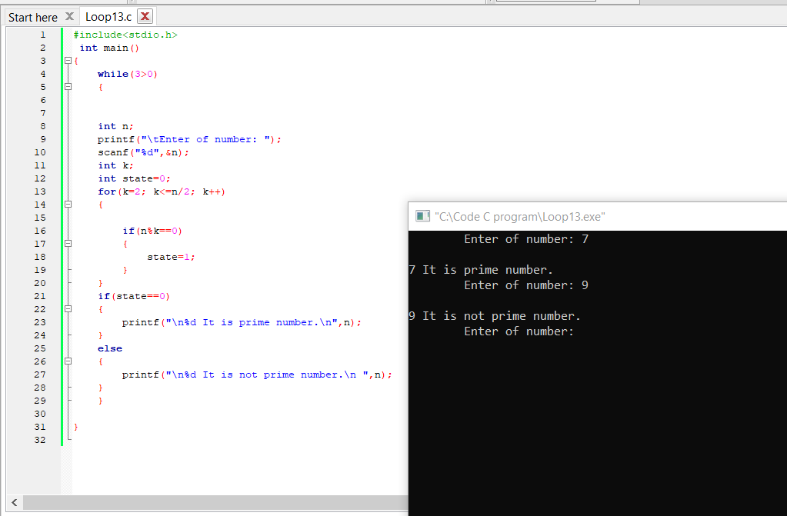Problem13: write c program to check a number is prime number or not.

Problem14: Write c program to print all prime number between 1 to n.

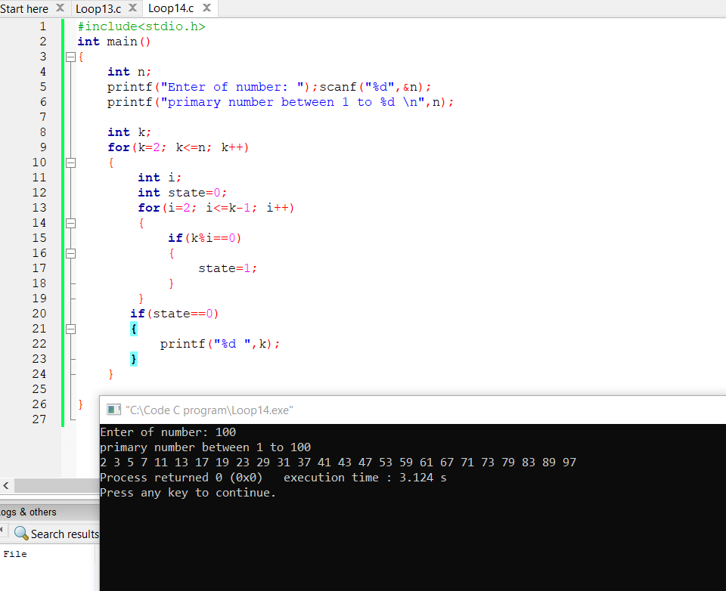

Problem15: write c program to find sum of all prime number between 1 to n.

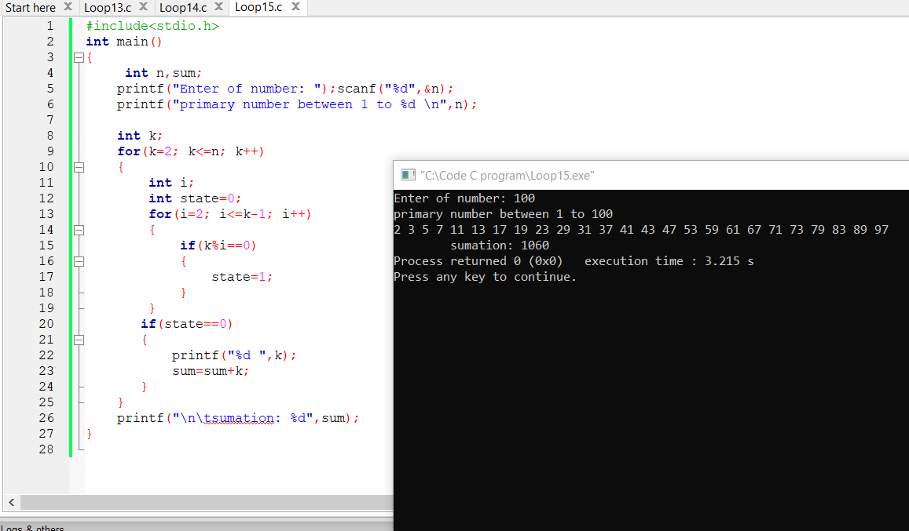

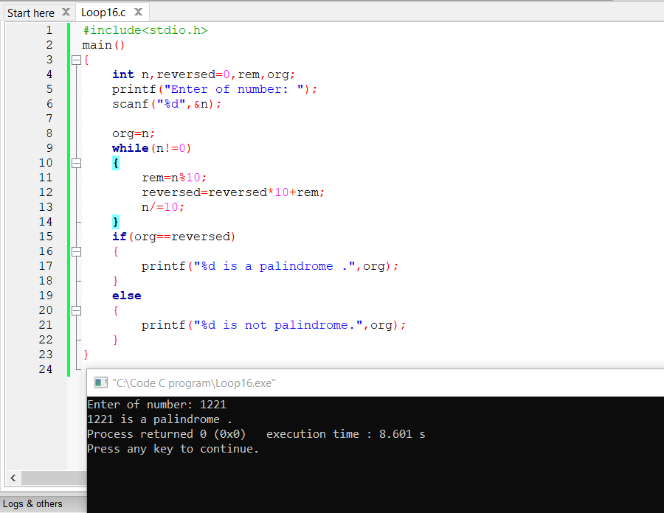Problem16: Write c program to check whether a number is palindrome or not.

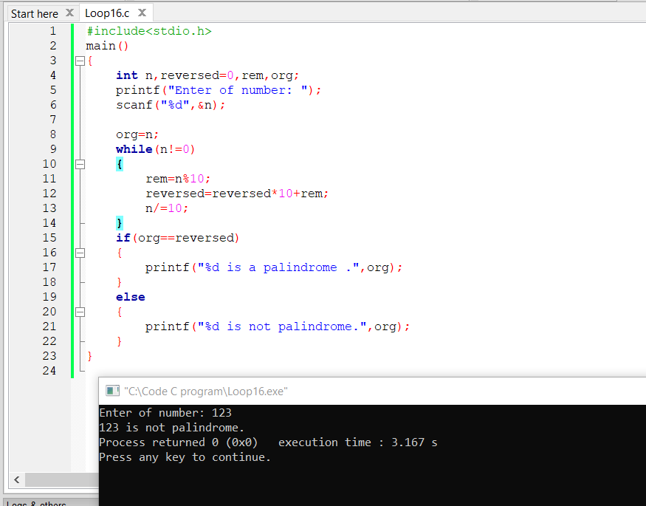

Problem17: write c program to check a number is Armstrong or nit.

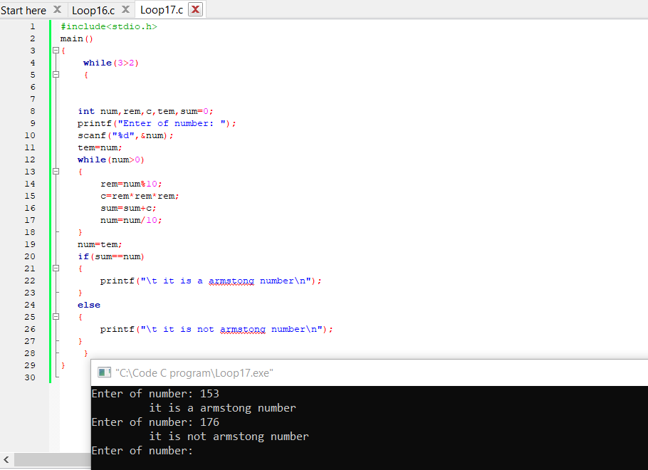

Problem19: Write a c program to check a number is perfect number or not.

